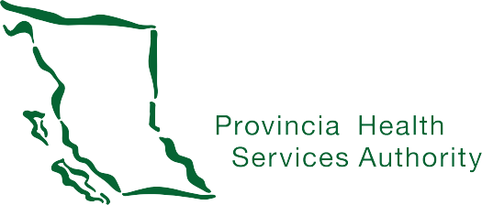

PROVINCIAL LANGUAGE SERVICE


VIRTUAL
TOWN HALL
January 14, 2021

6:00 to 8:00 pm
Zoom webinar

Join us at the Provincial Language Service's Virtual Town Hall to learn more about:
- How we work with the Deaf, Deaf-Blind and Hard of Hearing community.
- Medical sign language interpreting in B.C.
- Who the service provider will be for the new contract term.
Deaf Interpreters, ASL Interpreters and CART provided.

To register: www.tinyurl.com/pmslis Questions: PMSLIS@phsa.ca

