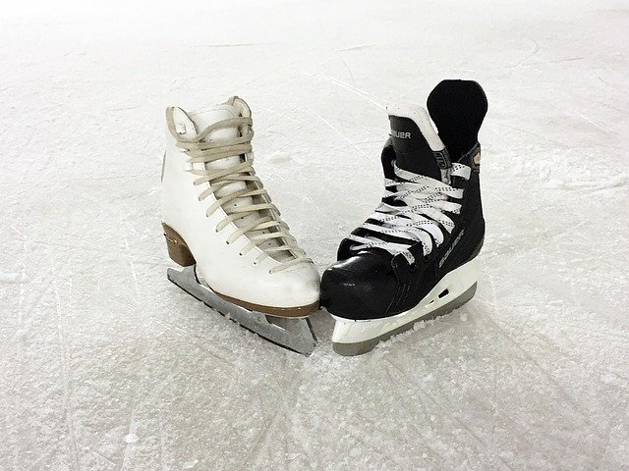  - Sat. March 14, 2020  3:15 pm to 5:15pm Registration: $20.00  Why should you attend?  The BC Deaf Sport Federation (BCDSF) is a non-profit charitable organization which provides provincial, national and international sporting opportunities for the Deaf and Hard of Hearing.  BCDSF promotes awareness of BC Deaf and Hard of Hearing athletes and provides services and supports in the area of competition and recreational sports. We need you to help raise funds – by register and join the fun and collecting pledges on behalf of BCDSF. We will donate 50% to the World Deaf Ice Hockey Championship 2021 that will be held in Vancouver, BC.  Chairperson: Ronald Fee
  Ice Skate-A-Thon
  ____
  Come and have fun and support BC Deaf and Hard of Hearing athletes
  ____
  Where: Sportsplex 20165 – 91A Avenue Langley, BC Ice Rink #4
  ____
  Prize for the participant who collected the most pledges! Contact the office for the pledge forms.
  ____
  You can pay by cash or E-Transfer to info@bcdeafsports.bc.ca Please RSVP by March 6
  BC Deaf Sports Federation
  #4-320 Columbia Street
  New Westminster, BC
  V3L 1A6
  info@bcdeafsports.bc.ca
  RSVP by March 6, 2020

