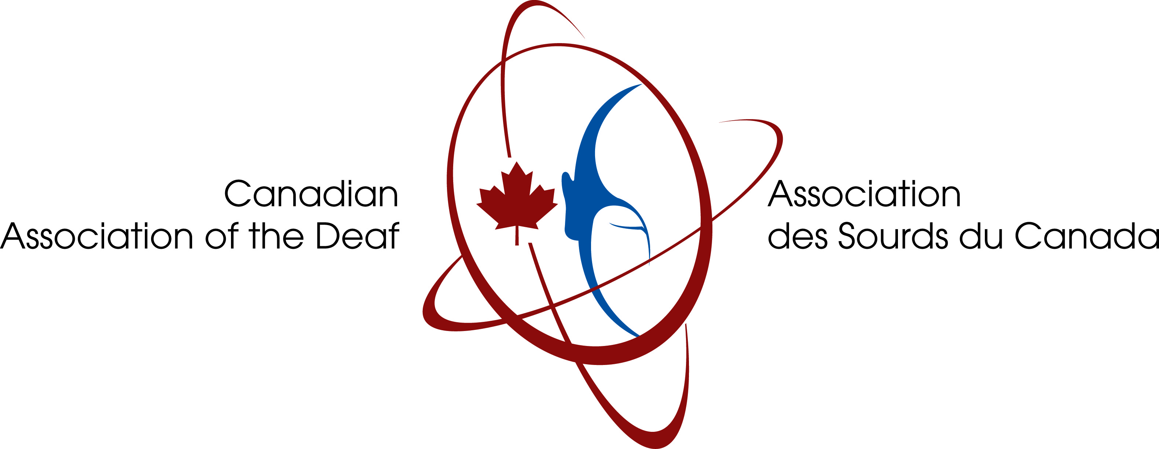

Suite 606 • 251 Bank Street • Ottawa, Ontario • K2P 1X3
(613) 565-2882 • http://www.cad.ca • info@cad.ca
Charitable Business No. 10807 5003 RR0001 No. d’entreprise charitable

Job Opportunity: Project Coordinator

The Canadian Association of the Deaf – Association des Sourds du Canada has applied for federal funding to support a 19-month project that requires a highly skilled and very energetic Project Coordinator. The work is related to federal accessibility legislation and the United Nations Convention on the Rights of Persons with Disabilities.

Starting date: 5 September 2016
End date: 30 March 2018

Responsibilities: This is a very demanding position that involves a broad range of responsibilities. You will:
- work together with various disability organizations across Canada as partners in our project activities;
- research, analyze, and write materials relating to federal accessibility legislation and the United Nations Convention on the Rights of Persons with Disabilities;
- create “Simple Language” versions of complex government information;
- produce ASL-LSQ video versions of the information;
- produce text versions to accompany the Signed videos;
- disseminate and promote these products;
- manage website and social media activities.

Requirements:
- Proven experience in working in partnership with different kinds of charitable organizations, including both Deaf and non-Deaf organizations.
- Proven expertise in creating easy-to-understand text and Signed video versions of complex information such as government publications -- include samples in your application.
- Highly skilled in social media and website management.
- Strong knowledge of the United Nations Convention on the Rights of Persons with Disabilities.
- Proven experience with federal legislation and working with governments on policy development and analysis.
- Research, analysis, and evaluation/survey (data collection) skills and experience.
- University degree, preferably in Canadian political science or related discipline.
- Deep understanding of Deaf culture and language, and of disability in general.
- Involvement in the disability/cross-disability community (advocacy, not sports or arts).

Languages: Complete fluency in at least two of the following is required: ASL, LSQ, written English, written French.

Location: Preferably, but not necessarily Ottawa.

We offer an excellent salary and benefits. This is a full-time position (25 hours/week).

Send your resume by 17 August 2016 to jroots@cad.ca . No phone calls! Only those applicants chosen for an interview will be contacted.

Due to the nature of this position, preference will be given to applicants who are Deaf.

This position is dependent upon funding approval by the federal government.

